

**We Can Help**

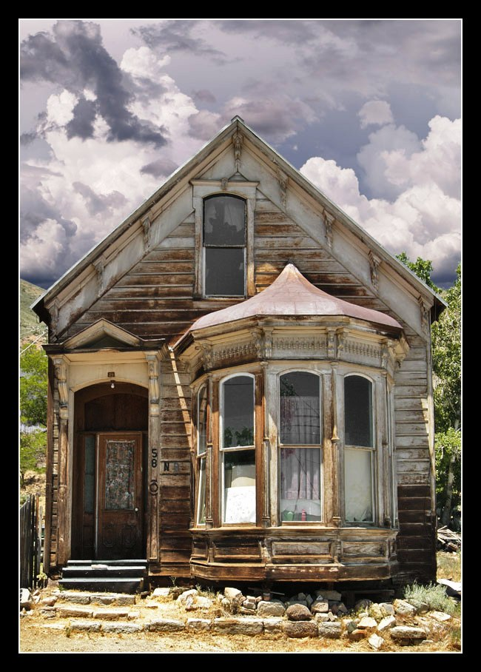

[](http://www.google.com/imgres?q=handicapped+sign&um=1&hl=en&gbv=2&biw=1024&bih=587&tbm=isch&tbnid=dly72AIjvB1yuM:&imgrefurl=http://en.wikipedia.org/wiki/File:Handicapped_Accessible_sign.svg&docid=j7Ivla8QSlhEbM&imgurl=http://upload.wikimedia.org/wikipedia/commons/thumb/e/eb/Handicapped_Accessible_sign.svg/451px-Handicapped_Accessible_sign.svg.png&w=451&h=451&ei=F-roTub-F6iZiAK9j9HzCw&zoom=1)

*Ask about accessibility improvement programs*.

City of Huron

The City of Huron can help you!

Home Owner Rehabilitation Program

* Assists in the repair of homes for low-income families.
* Provides healthier and safer homes.
* Allows the balance of the loan to be deferred for up to 30 years.
* Maintains your home up to code with city regulations.
* Enhances your community.

[](http://www.google.com/imgres?q=equal+housing+lender+logo&hl=en&sa=X&biw=1024&bih=587&tbm=isch&prmd=imvns&tbnid=T8dzFxwUssmTDM:&imgrefurl=http://www.membersonline.org/&docid=xosXGamKFLltoM&imgurl=https://www.membersonline.org/images/logo_eho_white.gif&w=300&h=300&ei=S9boTorZCI3PiAKR1-GaDA&zoom=1)

Program Benefits



Does your home need repair?

36311 Lassen Ave.

P.O. Box 339

Huron, CA 93234

E: cityofhuronhousing@gmail.com

P: 559-945-2241

F: 559-945-2609

“The City of Huron is dedicated to providing efficient and effective quality municipal services that enhance the quality of life that the community of Huron deserves.”

If you own and occupy your home it is possible we can help you obtain a 0% interest loan to make home repairs.

**Eligible Repair Items…**

* Foundation & structural problems
* Roofing
* Windows
* Heating
* Plumbing
* Kitchen & Bath
* Floors
* Fences
* Lead-Based paint (Interior/Exterior)
* Pest Control
* Smoke Alarm
* Fireplace

[](http://www.google.com/imgres?q=new+house+clipart&hl=en&sa=X&gbv=2&biw=1024&bih=587&tbm=isch&tbnid=7gFgnGP2C4rn4M:&imgrefurl=http://kmaru16.blogspot.com/2010/10/anniversary.html&docid=4DOB9uO7CACLfM&imgurl=http://3.bp.blogspot.com/_pxERgxWoU7Q/TMrkXO5GB-I/AAAAAAAAB1s/U-iuuSwoB14/s320/house_clipart.jpg&w=320&h=320&ei=vr7nTvTFCOHg2AX1yuCmCQ&zoom=1)

Or any other minor or substantial repair, the City of Huron might be able to help you.

**We are accepting applications.**

**Who can apply?**

Any person who owns and occupies their home with a combined income that does not exceed the amounts for the family size indicated.

**State Income Limits for 2013\***

|  |  |
| --- | --- |
| **Family**  **Size** | **Total Family Income** |
| 1 | $32,100 |
| 2 | $36,700 |
| 3 | $41,300 |
| 4 | $45,850 |
| 5 | $49,550 |
| 6 | $53,200 |
| 7 | $56,900 |
| 8 | $60,550 |

*www.hcd.ca.gov

[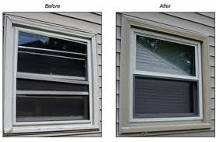](http://www.google.com/imgres?q=window+repair+before+and+after&hl=en&gbv=2&biw=1024&bih=587&tbm=isch&tbnid=a4yQxUiisNoCMM:&imgrefurl=http://www.windowdiscountersonline.com/Real_Estate_Pros/&docid=ChZPUx50QXAbQM&imgurl=http://www.windowdiscountersonline.com/Real_Estate_Pros/before_after.jpg&w=400&h=263&ei=77znTp77J6Wl2AWrxpjRCA&zoom=1)

[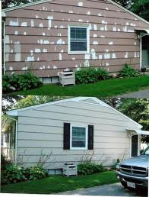](http://www.google.com/imgres?q=before+and+after+painted+houses&hl=en&gbv=2&biw=1024&bih=587&tbm=isch&tbnid=hwFwS_4ybxdnbM:&imgrefurl=http://www.allteriorpainting.com/gallery/index.html&docid=F0VItnXJ6LXDjM&imgurl=http://www.allteriorpainting.com/gallery/images/house%20painting%20before%20and%20after.jpg&w=480&h=632&ei=kr3nTvq3HYe62gWC38jfCA&zoom=1)

1. Call the City at (559)945-2241 to place your name on the Program interest list.
2. The City will mail you an application once your name is reached on the list.
3. After reviewing your application, City staff will conduct an assessment of repairs needed at your home.
4. If you are approved to receive funds within the established regulations, City staff will work with you to help complete the process and get the repairs started.

[](http://www.google.com/imgres?q=repairing+roof+clipart&hl=en&sa=X&gbv=2&biw=1024&bih=587&tbm=isch&tbnid=QGt4VqLoNs6tGM:&imgrefurl=http://moethehandyman.com/&docid=dShfylLTf4oGuM&imgurl=http://www.moethehandyman.com/_/rsrc/1319254041210/home/0511-0903-2623-1938_Handyman_Holding_a_Bunch_of_Tools_clipart_image.jpg?height=300&width=320&w=319&h=300&ei=oefnTuesC6iSiALM9KGUBw&zoom=1)

How can I get started?

It’s very simple…

How can you help me?